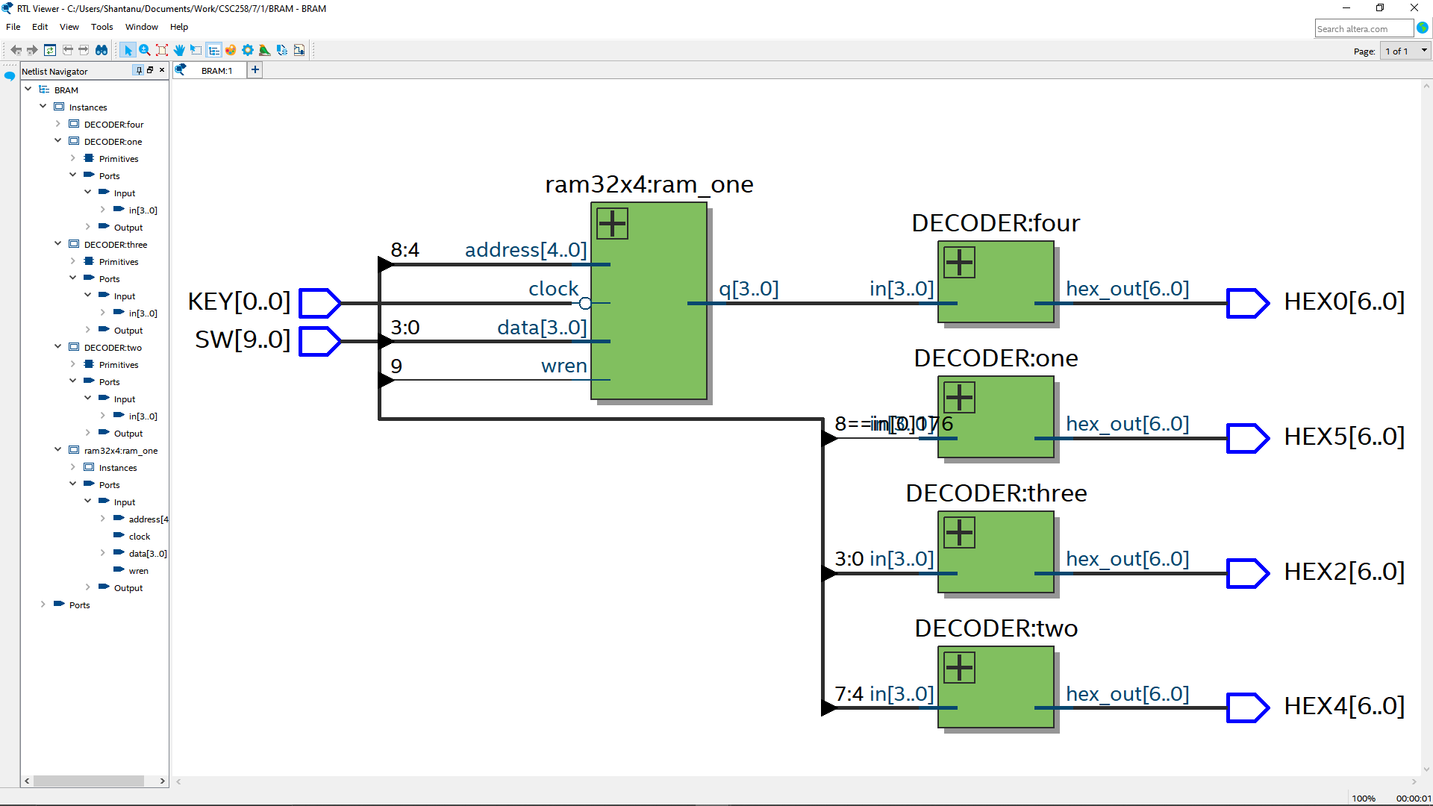

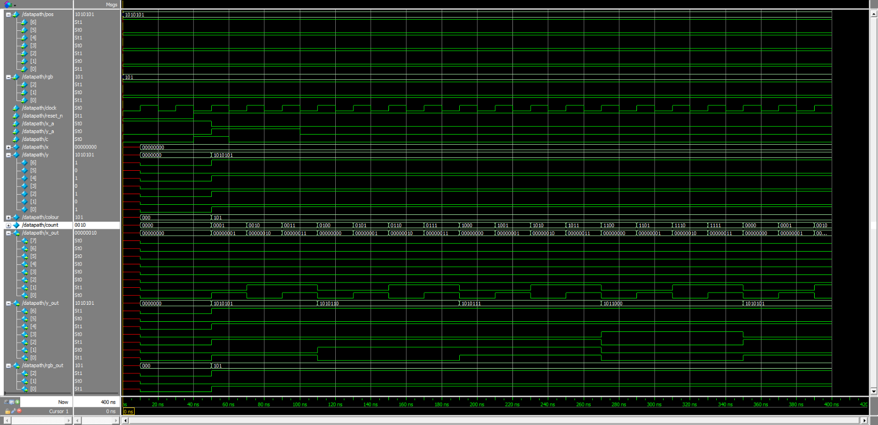

|  |  |  |  |  |
| --- | --- | --- | --- | --- |
| State | LOAD_X | LOAD_Y | LOAD_C | plot |
| X_L | 1 | 0 | 0 | 0 |
| Y_L_C | 1 | 1 | 1 | 0 |
| d | 1 | 1 | 1 | 1 |

